|  |  |
| --- | --- |
| 1 | Population Calculation |

|  |
| --- |
| **Code** |

%Taking the inputs

p0 = input('Enter the population at time(0): ');

d = input('Enter time in which population will be double: ');

%Have to calculate at 5,10,15 years

t = [5 10 15];

l = length(t);

%Population

p = ones(1,3)

for i = 1:l

temp = pow2( t(i) / d);

x(i) = floor( p0 * temp);

end

%Output

'The populations at 5,10 and 15 years are gradulally '

x

%Drawing graph

plot(t,x,'p-b');

xlabel('Years(t)'); ylabel('Population');

title('Population at different years');

|  |
| --- |
| **Output** |

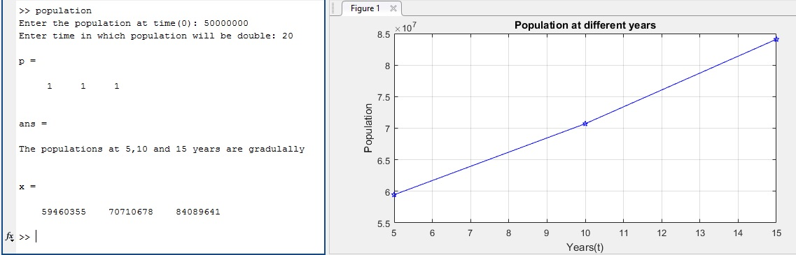

|  |  |
| --- | --- |
| 2 | Population Calculation |

|  |
| --- |
| **Code** |

MSG1 = 'Enter the following data--> '

m = input('mass(m): ');

x1 = input('Initial position(x1): ');

x2 = input('Velocity(x2): ');

F = input('Given Force(F): ');

k = input('Spring constant: ');

c = input('Damping constant: ');

%Calculating acceleration

Acceleration = -((k * x1) / m)-((c * x2) /m)+(F / m);

%Showing output

Acceleration

|  |
| --- |
| **Output** |

